PSSI Science Project Reporting Template

️ | The PSSI Implementation Team is compiling a technical report to demonstrate the important research and advancements made by the Science Branch through the PSSI funding. The technical report will include a 3-4 page summary (including graphics and figures) for each project to show their key results and findings. Please fill in the following fields and sections for your project to be included in the report. Feel free to include and draw from any reports or presentations previously created through your research.  A plain language science bulletin will also be created to follow up on last year’s “DFO Pacific Region Science Bulletin, 2024. New research and monitoring for Pacific salmon and their ecosystems.” While the first bulletin introduced project backgrounds, methods, and timelines, this new bulletin will highlight the projects’ results, key findings, and conclusions with links to reports and data available. The bulletin will include a 1-2 page summary for each project gleaned from the content entered below.  ️ Completed forms are due January 7, 2026.  *Please include or send separately any graphics or pictures (with photo credits) that will help promote the projects.

PART 1: PROJECT METADATA

General Project Information
Project ID (number) | Project Title
2394 | Enhanced salmon bycatch monitoring and sampling in the Pacific region groundfish trawl fishery
Project Leads | Collaborations and External Partners
Cory Lagasse, Kathryn Fraser | Internal:  Nicholas Komick  Emily Braithwaite  Brenda Ridgway  Maria Cornthwaite  Maureen Finn  Lindsay Richardson-Deranger  Mike Hawkshaw  External:  Canadian Groundfish Research and Conservation Society  David Suzuki Foundation  Archipelago Marine Research Ltd.  JO Thomas and Associates Inc.
Location (if applicable)
Pacific Region

Geographic and Stock Information
Salmon species (if applicable) | Waterbodies (if applicable)
All Oncorhynchus spp. | Click or tap here to enter text.
Life history phases (if applicable) | Region
Marine | Pacific region
Stock (if applicable) | Population (if applicable)
Click or tap here to enter text. | Click or tap here to enter text.
Conservation Unit (if applicable)
Click or tap here to enter text.

🧰 PART 2: PROJECT METRICS

Project Outputs
Include any anticipated outputs denoted as (in progress). Please include links to any outputs available online so they can be referenced in the report.
List scientific publications and technical reports (with links)
Two manuscript reports currently published:
Review of Salmon Bycatch in the Pacific Region 2022/23 Groundfish Trawl Fishery and Preliminary Results of an Enhanced Monitoring Program
Salmon Bycatch Monitoring and Sampling Results for the Pacific Region 2023/24 Groundfish Trawl Fishery

One additional manuscript report submitted for publication

List datasets generated (with links)
-Catch and biological data of salmon bycatch in the groundfish trawl fishery, 2022 – present (dataset not publicly available due to privacy restrictions, but data tables published in reports)
Describe dataset locations and data management systems
Catch data:
- GFFOS database, except for 2022-2024 where independent lab verification occurred and was not incorporated into database estimates
Coded wire tag data:
- Stored on mark recovery program database
Genetics data:
- No database for storage but spreadsheets with data are retained by the MGL
List code, programs, or other software created (with links)
The R workflow for importing, cleaning and processing data sets, then generating a data report and tables are found at: https://github.com/clagasse/gfsalmon

List communication or social media products
PSSI feature story: https://www.dfo-mpo.gc.ca/campaign-campagne/pss-ssp/stories-articles/2026-collab-protect-proteger-chinook-eng.html

List and describe field work completed
Over 44,000 salmon heads (primarily Chinook) were collected for biological sampling and validation as part of this project. The samples were collected by dockside observers and fishers as an additional sampling component to routine validation and fishing operations. Salmon heads were sent to JO Thomas and Associates for identification to species, collection of coded wire tags, and DNA tissue sampling.
List and describe samples collected/analyzed (number of samples)
As of December 31, 2025, 11,997 Chinook salmon were assigned to stock of origin by the following methods:
CWT – 5,416 fish
GSI – 5,626 fish
PBT – 935 fish.

These samples were collected from 44,217 salmon heads that were independently counted and processed by JO Thomas and Associates Ltd. 37,625 Chinook salmon heads within these samples were scanned for coded wire tags.

Collection of salmon head samples is ongoing until the end of this year’s groundfish trawl fishery on February 20, 2026.
List and describe large capital assets or equipment acquired
None

PART 3: WRITTEN CONTENT

Highlights
Please summarize in 2-3 bullets:
- The main idea of the project
- Key findings
- Implications of these findings for salmon and decision-makers
- For a more technical audience, but still as plain language as possible
- Bycatch of Pacific salmon in the groundfish trawl fishery has emerged as an important management issue due to the potential impacts on stocks of conservation concern, particularly for Chinook salmon, which constitute the majority of salmon bycatch. Beginning fall 2022, an enhanced monitoring program for salmon bycatch was implemented to provide accurate estimates of catch by species and to characterize the stock composition of Chinook salmon.
- The monitoring program captured large fluctuations in Chinook salmon bycatch with total catches peaking at 26,273 individuals during the 2022/23 trawl fishery followed by a steep decrease to 7,040 individuals for the 2024/25 trawl fishery. This marked reduction coincided with the implementation of a salmon bycatch management plan in 2024, which included the introduction of a fleet-wide Chinook salmon bycatch cap of 9,500 individuals.
- Representative sampling across three years of fishing improved our understanding of the stock composition of Chinook salmon bycatch, including stock-specific catches and catch of Chinook salmon coded-wire tag (CWT) indicator stocks. Across all years examined, the majority of Chinook salmon bycatch originated from stocks in the continental United States, whereas Canadian-origin bycatch was dominated by the Fraser River Fall 4(1) stock.

Background
Please provide 1-2 paragraphs to summarize
- The relevant biological, environmental, and/or management context
- What knowledge gap or demand were you trying to fill?
- Collaboration and partner relationships
The Pacific Region groundfish trawl fishery is one of the largest commercial fisheries in British Columbia by catch volume and value. Management of the fishery is informed by a comprehensive monitoring program that includes mandatory electronic monitoring and dockside validation of all catch. In recent years bycatch of Pacific salmon, particularly Chinook salmon, has emerged as a management issue due to the potential for impacts on stocks of conservation concern. In trawl fisheries, salmon are a prohibited species that cannot be targeted or sold, but until recently monitoring requirements for salmon bycatch were no different than those applicable to all catch species and representative information on catch by stock were not available.

In collaboration with the Groundfish Trawl Research and Conservation Society, the groundfish trawl industry, non-profit organizations, and monitoring service providers, DFO developed an enhanced monitoring and sampling program for salmon bycatch to address knowledge gaps and inform management of the fishery. The program was designed to provide accurate estimates of salmon bycatch by species and determine impacts on Chinook salmon stocks of concern by estimating stock composition and coded wire tag catches. Enhanced monitoring was initiated in September 2022 and has continued until February 2026, covering multiple fishery years and informing the development a salmon bycatch management plan for the trawl fishery.

️ Methods and Findings
Please insert a few paragraphs to summarize:
- Main methods used
- Products and tools produced
- Advancements in methodology, technology, and application
- Advancements in communication and knowledge transfer
- Key results and information generated
Commercial groundfish trawl catch is monitored and reported using a combination of fisher logs, audits of independent at-sea electronic monitoring, and dockside observer validation of landed catch. Prior to enhanced monitoring, Pacific salmon were required to be released and catch estimates were based primarily on fisher logs and at-sea observer data, with limited, opportunistic biological sampling of catch. Retention and sampling requirements for Pacific salmon were revised to enable accurate estimation of the number of salmon caught by species, and accurate estimation of stock composition for Chinook salmon catch. The key changes implemented as part of the enhanced monitoring program were to: 1) require mandatory retention of salmon bycatch from all option A trawl vessels (covering all vessels that fish using mid-water trawl nets); 2) independently validate all salmon bycatch, either during trip offloads by dockside observers or by sampling of retained heads; and 3) sample CWT and DNA tissue samples representatively from a subset of Chinook salmon bycatch.

The enhanced monitoring program provided independently validated estimates of salmon bycatch over three years of the groundfish fishery, with data collection currently ongoing for a fourth year. Monitoring procedures, analysis methods, and annual results were published in technical reports (Lagasse et al 2024, Lagasse et al 2025), providing the first comprehensive, publicly available reporting on salmon bycatch in the trawl fishery. The new monitoring requirements were successfully implemented for all Option A trawl vessels (over 35 active vessels each year) and nearly 12,000 Chinook salmon were identified to stock-of-origin using genetic stock identification (GSI), parentage-based tagging (PBT), and CWT methods. These samples were used to determine Chinook salmon stock composition and catch of CWT indicator stocks in a statistically representative manner.

Monitoring results revealed large fluctuations in salmon bycatch across years, while stock composition of Chinook salmon remained relatively stable. Chinook salmon bycatch increased drastically in 2022 coinciding with the first year of the enhanced monitoring program, peaking at a historic high of 26,237 Chinook salmon (out of 28,183 Pacific salmon) that was more than double any previous years since 2008. Bycatch remained relatively high during the following year with 21,696 Chinook salmon caught during the 2023/24 trawl fishery. Following implementation of a salmon bycatch management plan, Chinook salmon bycatch plummeted to 7,040 Chinook salmon for the 2024/25 trawl fishery. Stock composition across the three years of monitoring data showed that the majority of these Chinook salmon originated from the continental United States. Among Canadian stocks, most bycatch originated from the Fraser Fall 4(1) stock, which includes the Harrison River and Chilliwack River CWT indicator stocks.

Insights
Please insert a few paragraphs to summarize:
- What this project has added to knowledge about salmon populations, health, or ecosystems.
- How this project informs salmon management:
  - decisions
  - policy guidance
  - trade-offs
  - planning
- Addition of knowledge to understanding:
  - limiting factors/stressors/threats/ pathways of effects/risks
  - biologically significant thresholds
  - cumulative impacts
- Sources of uncertainty
Results from the enhanced monitoring program provide foundational information for fisheries management, and can contribute to our knowledge on the spatio-temporal distribution of Chinook salmon stocks. Accurate estimates of salmon catch by species is critical to track and manage the fishery, while stock composition data allows the evaluation of catch of Chinook salmon by stock. Many salmon-directed fisheries are managed to minimize impacts on stocks of concern, such as Fraser spring and summer Chinook salmon, and representative estimates of stock composition in the trawl fishery allow these impacts to be accounted for in run reconstructions and considered in risk assessments, Species at Risk Act listing advice, and other management decisions. The groundfish trawl fishery operates year-round and fishes in areas and times that are not typically represented by other fisheries, therefore the samples and stock identification information collected help to fill gaps in our understanding of when and where Chinook stocks are present within the Pacific Region.

Information generated from the enhanced monitoring program has already been operationalized to develop a salmon bycatch management plan for the trawl fishery. The management plan includes a fleet-wide Chinook salmon bycatch cap of 9,500 fish along with individual vessel bycatch caps. In response to these new restrictions, the groundfish trawl industry has been investigating the use of exclusion devices – escape hatches that allow salmon to swim out of nets prior to hauling in – among other methods for reducing salmon bycatch. These regulations and changes in fishing practices have already mitigated impacts on Chinook salmon, decreasing catches by over two thirds from 2023/24 to 2024/25.

⏩ Next Steps
Please insert 1-2 paragraphs to summarize:
- Remaining knowledge gaps and recommendations for future studies
- How can/should the project findings be operationalized for salmon conservation and management?
The enhanced monitoring program represented three and a half years of salmon bycatch in the groundfish trawl fishery, however, ongoing monitoring is needed to inform management of the fishery and evaluate potential impacts on stocks of concern. The groundfish trawl fishery is a year-round, multi-species fishery that may vary in the distribution of effort and catch over time in response to regulations, market incentives, fish stock abundances, and other factors. Therefore, stock composition and catch patterns observed during the enhanced monitoring program should not be considered representative of future years. There is currently uncertainty in future funding and capacity for representative sampling of DNA tissue and CWTs to estimate stock composition, which may lead to information gaps in the future. Continued monitoring, along with communication and collaboration among the trawl industry, advisory groups, First Nations, and DFO, is important for the adaptive management of salmon bycatch in the trawl fishery moving forward.

📈 Tables and Figures
Please provide captions and numbering for any tables and figures. Graphics can be copied below or e-mailed separately.
- Include a brief caption with each figure and table in the box below
- Number each table and figure, and include references in the above sections where appropriate.
- 1-3 figures are recommended per project
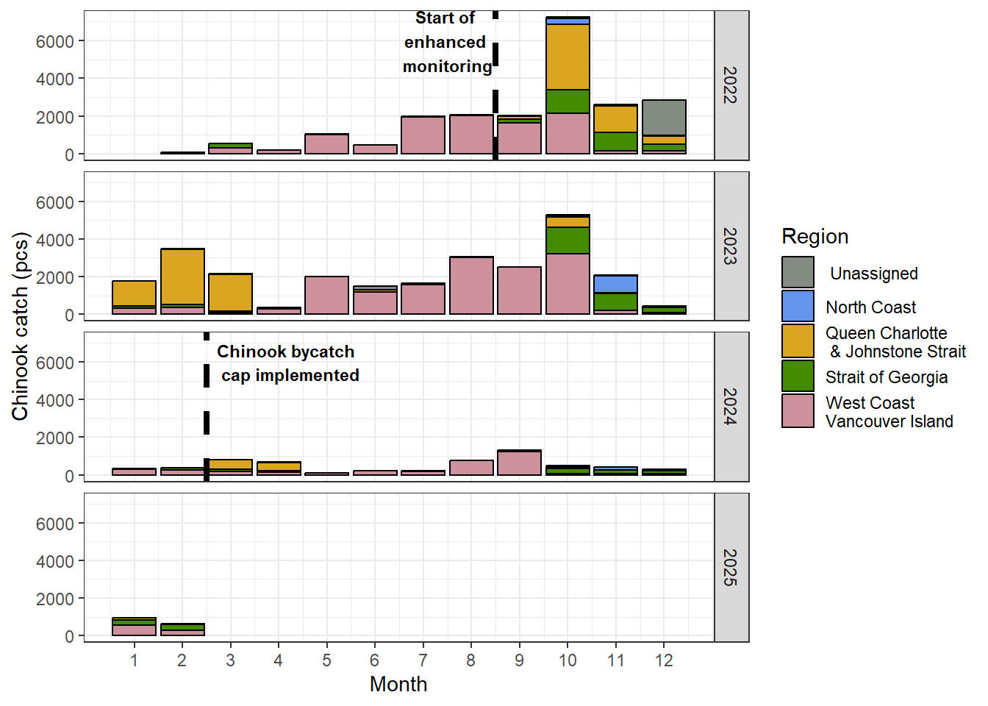

Figure 1 - Chinook salmon bycatch by month and region in the groundfish trawl fishery from 2022 to the end of the 2024/25 fishery on February 21, 2025. The enhanced monitoring program and changes to retention requirements began on September 22, 2022. Chinook salmon bycatch since February 21, 2025 is not yet available or shown.

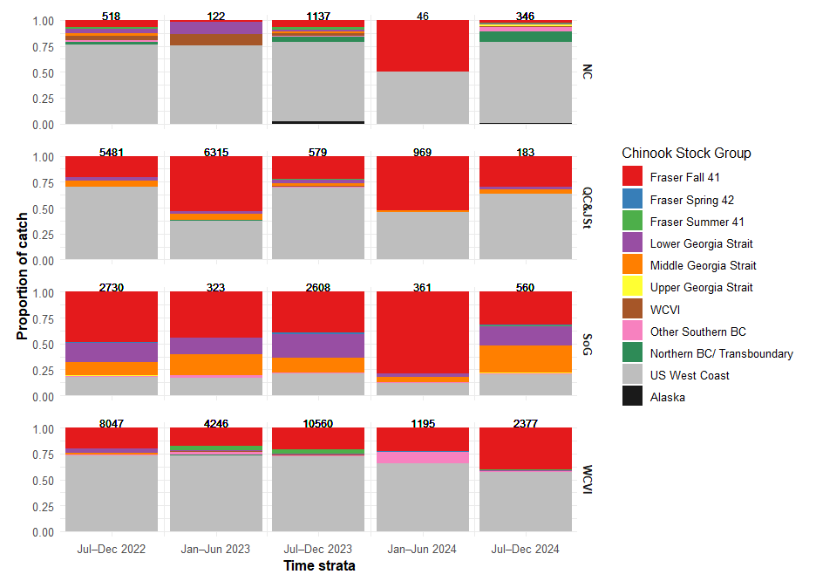
Figure 2 – Chinook salmon stock composition by half-year time strata and catch region using CWT and GSI-PBT stock identification methods for bycatch occurring between September 2022 to December 2024. The numbers above each bar represent the catch of Chinook salmon within each time and region combination. The regions shown are as follows: NC = North Coast, QC&JSt = Queen Charlotte and Johnstone Strait, SoG = Strait of Georgia, and WCVI = West Coast Vancouver Island. The Other Southern BC stock group includes Fraser Spring 5(2), Fraser Summer 5(2), Boundary Bay Fall 4(1), Mainland Inlet Chinook stocks.

📈 References
Include full references for any publications referenced in other sections. Please format references in Harvard style according to Instructions to Authors for the Canadian Journal of Fisheries and Aquatic Sciences, at Canadian Science Publishing.
Lagasse, C.R., Fraser, K.A., Braithwaite, E., and Komick, N. 2025. Salmon bycatch monitoring and sampling results for the Pacific Region 2023/24 groundfish trawl fishery. In Canadian manuscript report of fisheries and aquatic sciences. Fisheries and Oceans Canada. doi:10.60825/D0E4-PP46.

Lagasse, C.R., Fraser, K.A., Houtman, R., Grundmann, E., Komick, N., Brien, M.O., Braithwaite, E., and Cornthwaite, A.M. 2024. Review of Salmon Bycatch in the Pacific Region 2022/23 Groundfish Trawl Fishery and Preliminary Results of an Enhanced Monitoring Program. Can. Manuscr. Rep. Fish. Aquat. Sci. 3273: 3273: v + 35 p.

